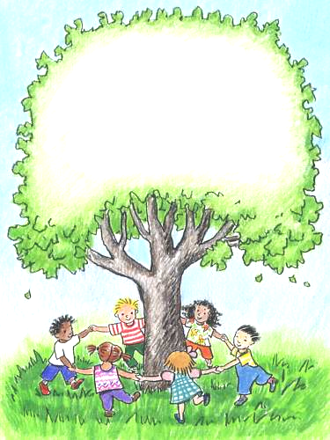
Boulevard Academy
Waiting List Application
Date: ____________

Name of Child/ren: ______________________________________

Age(s):________________

Date of Birth: _______________________

Preferred schedule (Please fill in all that apply):

Desired start date/season: ____________________

Full Time (30+ hrs per week) Part Time (less than 30hrs per week)

Monday Tuesday Wednesday Thursday Friday

Arrival Time: ____________ Departure Time: ____________

School preference (Please check):
Boulevard Little People Academy Boulevard Babies & Pre-K Academy

We understand there is a registration fee required to be placed on the waiting list. The fee for a full time slot (30 hours or more per week) is $300.00 and $250.00 for part time (less than 30 hours per week). This will secure our place on the waiting list and will NOT be deposited until BLPA or BBPKA has confirmed our spot in their program. If we no longer need the space, we will inform BLPA administration as soon as possible.

Parents’ name(s):______________________________________________________

Address:__________________________________________________________________

Phone/cell: ________________ Home:________________ Work:_________________

Email address: _____________________________

Deposit paid: ____________

Make checks payable to “BLPA” - drop off or mail to: 470 Boulevard Way, Oakland, CA 94610

Signature of parent/guardian: Date:

_____________________________ _________________

